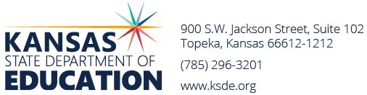
Revised August 1, 2024
2024-25 Bonds Requested

2023-2024 Bonds Retired + PPI (Cap) = $590,798,562

USD | District Name | Election Date | Amount Requested | * Amount Against Cap
105 | Rawlings County | 8/6/24 | 29,900,000 | 0
355 | Ellinwood | 11/5/24 | 8,500,000 | 0
TOTAL AGAINST CAP $0
BOND AUTHORITY REMAINING $ 590,798,562

* 1) Only the amount exceeding 14% of the district's assessed valuation counts against the cap.
2) Districts that have not issued bonds for 25 years do not count against the cap.
3) No single bond issue will count more than $175 million against the cap.
4) Elections held after 7/1/22 that do not qualify for state aid will not be counted against the cap.
2025-26 ESTIMATED AUTHORITY calculated in November + Producer Price Index

T:bond elections/State board approval FY25/Bond int approval posted 8-1-24

